Infoboard Touch

/User Manual/

Table of Contents

* Introduction
* Main Features
  + Trip Info
  + Ecotronic
  + Diagnostic
  + Dyno
  + Digi Dash
  + Maintain
  + Expense
  + Assist
  + Date-Time
  + Log
  + Setup
  + Refuel
* Installation
  + Connector Types
  + Compatibility

Introduction

**Infoboard** is a multifunctional device that serves as a trip computer, digital dash, dynometer, car maintenance helper and diagnostic tool at the same time; all-in-one thanks to the contemporary 21st century technologies used in it.

This tool gives you a whole new way of communication with your car, and will become an irreplaceable assistant on every journey you take.

**Infoboard** connects directly to the engine control unit – ECU.

Virtually all of the 1992-2001 range of Honda models is supported. The installation is very easy and consists of identifying the DLC connector (see the instructions) and connecting the Infoboard.

In order to use all functions, a basic (very straightforward) setup is required. The user needs to set some values like the date/time, car weight, redline, fuel tank size, and the injectors’ size.

**Infoboard** can be connected or disconnected at any time; before or after the engine is started.

Main Features

# Trip Info

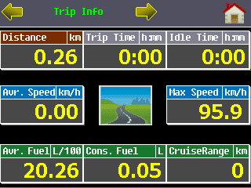/information about the current trip/

* Trip Distance
* Trip Time
* Idle Time
* Average Speed
* Max Speed
* Average Fuel Consumption
* Consumed Fuel
* Cruise Range

# Total Counters

/summary information about all the previous trips/

* Trip Distance
* Trip Time
* Idle Time
* Average Speed
* Max Speed
* Average Fuel Consumption
* Consumed Fuel
* Trips Started

# Trip List

/list of the previous trips displayed in a tabular style/

# Ecotronic

/game-like mode; used to encourage the eco driving style/

# Sensors

/car and engine sensors/

* Engine Speed
* Car Speed
* Map Sensor (MAP)
* Engine Temperature (ECT)
* Air Temperature (IAT)
* Throttle Position (TPS)
* Battery
* 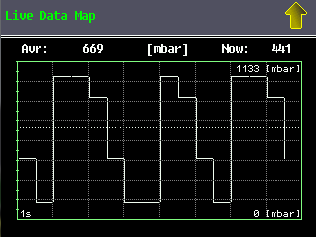Oxygen Sensor (02)
* Injector
* Ignition Advance
* Long Term Fuel Trim (LTFT)
* Short Term Fuel Trim (STFT)
* Alternator

# Injector Table

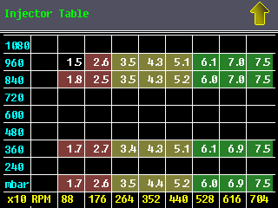/displays a real-time injector table /

# Ignition Advance Table

/displays a real-time ignition advance table/

# ECU DTC (Diagnostic Trouble Codes)

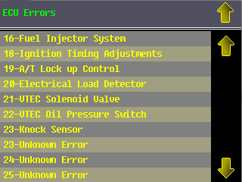/displays a list of the DTC/

# Clear DTC (Diagnostic Trouble Codes)

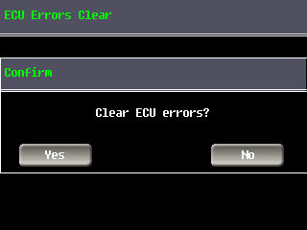/clears the active DTC errors/

# Digi Dash

/digital dashboard showing general information/

* 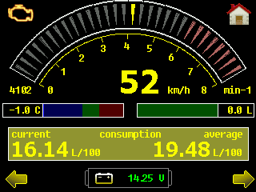VTEC Indication
* RPM Meter
* Engine Temperature
* Fuel Left (if set)
* Current Fuel Consumption
* Average Fuel Consumption
* Battery Voltage
* Current Speed
* Distance Travelled
* Cruise Range
* Trip Time
* Idle Time
* Date and Time

# Maintain

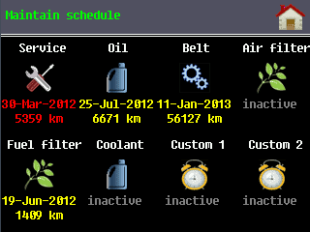/regular maintenance scheduler tool/

* Service
* Oil
* Belt
* Air Filter
* Fuel Filter
* Coolant
* Custom 1
* Custom 2

# Expense

/helps keep track of the expenses/

* 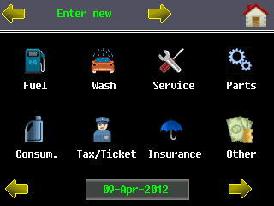Fuel
* Wash
* Service
* Parts
* Consumables
* Tax/Ticket
* Insurance
* Other

# Expense Listing

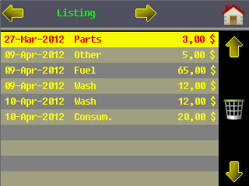/shows the expenses in a simple list view/

# Monthly Expenses / Totals

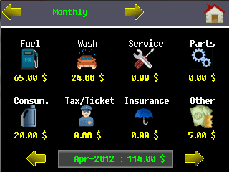/shows the monthly (or the total) expenses/

# Speed Guard Assist

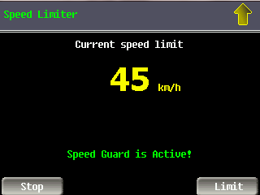/issues a warning tones when a given speed is reached/

# G-Sense Assist

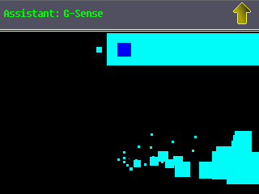/draws a graphic showing the g-forces/

# G-Graphic Assist

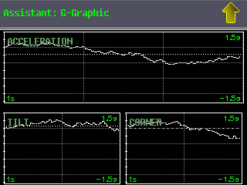/draws acceleration, tilt and corner g-forces/

# Calendar

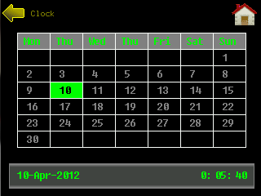/displays a simple calendar/

# Date/Time

/displays the current date and time/

# Log

/helps log the ECU errors periodically/

# Refuel

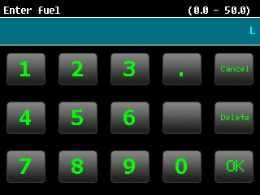/this is to notify the device that you have refueled the car/

# Setup

/configure the Infoboard/

* Tires Correction
* Injector Size
* Injector Cycles
* Red Line
* Tank Size
* Backlight
* RPM Detection
* Car Weight
* Eco Fuel Level
* Cycle Digi Dash Info
* Oscilloscope View Type
* Diagnostic Mode
* Time
* Date
* Sound
* Read Device ID
* Speed Run From km/h
* Speed Run To km/h
* Distance Run To
* Reset Trip Counters
* Reset Total Counters
* Reset Ecotronic
* Empty Fuel Tank
* Set Factory Settings

Installation

The installation of the **Infoboard** is meant to be as simple as possible. Put short, you need to wire the cables to your diagnostic connector and then setup the device by providing some data required for the calculations.

Connecting the **Infoboard** to the DLC (Data Link Connector) is a really simple task. No specific knowledge is required. The chance of breaking/burning the device is reduced to minimum, even if you connect the device improperly. The whole installation procedure is actually a straightforward two-step process:

* Find the diagnostic/service connector
* Connect the **Infoboard**

# Data Link Connector (DLC)

The diagnostic connector can be one of the following types:

**2 pins** – the first pin is ground and the second one is connection to the ECU (data pin)

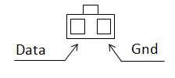

**3 pins (type 1)** – only two pins have wires connected here. The middle one is empty.

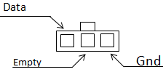

**3 pins (type 2)** – ground and data connection plus +12V line

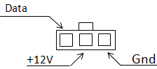

**5 pins** – used mostly in UK and US models from 1996 to 2001

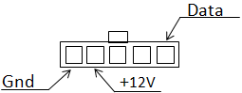

**16 pins (OBD2)** – this connector type is used in cars, manufactured after 2000 year

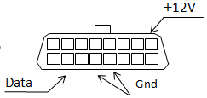

It is fairly easy to identify the proper pins even without the above images. All you need is a multimeter/voltmeter. Connect the negative test proble of the voltmeter to the cigarette lighter’s ground and then use the positive probe to find which pin has a constant +12V even when the engine is off. This is where you have to connect the **Infoboard**’s power supply line (red).

You can then find the ground pin by testing the pins using the negative probe while the positive one is connected to the aforementioned +12V pin.

The data line is not active when the starter/ignition key is not on the “Acc ON” or “Start” positions. When this line is active it will give +5V.

# Infoboard Cables

There are three wires coming from the **Infoboard** cable.

* **Red**: +12V (power supply line)
* **Black**: Ground
* **Yellow**: Data (connection to the ECU)

# Diagnostic/Service Connector Location

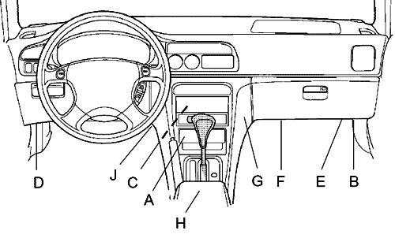

|  |  |  |  |
| --- | --- | --- | --- |
| Model | Year | Location | Type |
| Civic 5gen | 1992-1995 | B | 3 pins (type 1 and 2) |
| Civic 6gen | 1996-2001 | E | 3 pins (type 2) |
| Civic UK | 1994-1996 | B | 3 pins (type 2) |
| Civic UK | 1996-2001 | B | 5 pins |
| Prelude 4gen | 1992-1996 | C – behind the central console | 3 pins (type 1 and 2) |
| Prelude 5gen | 1997-2001 | G – in the front of the console on the passenger side | 3 pins (type 1 and 2) |
| Accord UK | 1996-1999 | F | 5 pins |

# Compatibility

List of the Honda models tested:

|  |  |  |  |  |  |  |
| --- | --- | --- | --- | --- | --- | --- |
| **Manufacturer** | **Model** | **Year** | **Engine** | **ECU** | **DLC** | **Compatibility** |
| Honda UK | Civic 1.6 SR VTEC | 1995 | D16Y2 | P1H | 3 pins Type 2 | 100% compatible |
| Honda UK | Civic 1.6 SR VTEC | 1997 | D16Y2 |  | 5 pins Type 1 | 100% compatible |
| Honda UK | Civic 1.6 | 1997 | D16Y3 |  | 5 pins Type 1 | 100% compatible |
| Honda UK | Civic 1.5 VTEC-E | 1996 | D15Z3 |  | 3 pins Type 2 | 100% compatible |
| Honda US | Civic 1.6 VTEC | 1995 | D16Z6 | P28 | 3 pins Type 2 | 100% compatible |
| Honda JP | Civic 1.5 VTEC-E | 1994 | D15Z1 |  | 3 pins Type 1 | 100% compatible |
| Honda JP | Prelude 2.3 DOHC | 1994 | H23 | P14 | 3 pins Type 1 | 100% compatible |
| Honda UK | Accord 1.8 VTEC | 1999 | F18B2 |  | 5 pins Type 1 | 100% compatible |
| Honda US | Civic Coupe 1.6 VTEC | 1994 | D16Z9 |  | 3 pins Type 2 | 100% compatible |
| Honda JP | Civic 1.4 | 1997 | D14A4 | P3Y | 3 pins Type 2 | 100% compatible |
| Honda UK | Civic 1.5 VTec | 1996 | D15Z6 | P2Y | 3 pins Type 2 | 100% compatible |
| Honda JP | Civic 1.6 VTi | 1998 | B16A2 |  | 3 pins Type 2 | 100% compatible |
| Honda UK | Civic 1.4 | 1995 | D14A2 |  | 3 pins Type 2 | 100% compatible |
| Honda US | Accord Coupe 2.0 | 1994 | F20B3 |  | 3 pins Type 2 | 100% compatible |
| Honda JP | Prelude 2.0 | 1997 | F20A4 |  | 3 pins Type 2 | 100% compatible |
| Honda JP | Prelude 2.2 DOHC VTEC | 1993 | H22 | P13 | 3 pins Type 1 | 100% compatible |
| Honda JP | Inspire 2.0 | 1996 | G20A |  | 3 pins Type 1 | 100% compatible |

 If you have installed the Infoboard in your car, and it is not in the list, please send us its data – manufacturer, model, year of production, engine code, ecu code, so that we can add it to the table.